A Midsummer Night’s Dream Performance – Flute Theatre
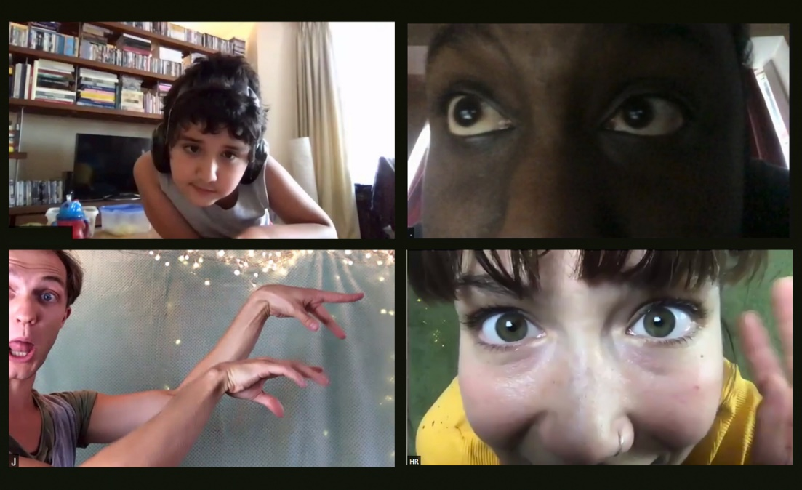
Flute Theatre Website
https://flutetheatre.co.uk/

Contact details for Kelly Hunter MBE
flutetheatrecompany@gmail.com
Kelly is more than happy to be contacted about her work.

Book a Performance
A Midsummer Night’s Dream Online, for autistic individuals and their families. October 12th - December 12th. Book HERE: https://flutetheatre.co.uk/contact/

PLEASE subscribe to newsletter
https://flutetheatre.co.uk/subscribe-to-our-newsletter/

VIMEOS
Flute Theatre have over 130 films on their vimeo channel. Here are the links to three of them.

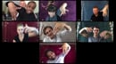
ADAPTING OUR WORK

https://vimeo.com/461074646

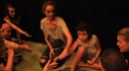
'HE SAID HELLO FOR THE FIRST TIME'

https://vimeo.com/456544289

"Lumen is a very happy eight-year-old, non-verbal, autistic boy who primarily uses gesture to communicate. He says a few words, although not always in context. He conveys his needs and emotions, as well as self-regulates by spinning, flapping his hands, jumping, swinging, chewing various objects, and using facial expressions. Lumen suffers from sensory processing disorder which translates into him being very sensitive to sound, light, temperature, and texture. He learns about his environment through touch and also by licking objects. He has difficulty with transitions, being flexible in situations, and understandably, being misunderstood. It is during these times that he harms others and himself. All of this makes his participation in Flute Theatre’s activities all the more profound. He has been given tools not offered anywhere else. He has been given a sense of security and familiarity, which for an autistic child, are not always easy to come by. He said ‘Hello’ for the first time after listening to Heartbeat Hellos for weeks; he was captivated for the entire hour of Pericles online; he smiled, laughed, and even emulated facial expressions of actors; and he has sung some of the songs he has heard from Flute’s Soundcloud as a way to self-regulate or to express joy." LIsha Rooney, Lumen's mother

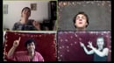
PERICLES ONLINE TRAILER
https://vimeo.com/446820065

Books
Shakespeare’s Heartbeat: Drama games for children with autism - https://flutetheatre.co.uk/hunterheartbeatmethod/our-scientific-research/
Cracking Shakespeare: A hands-on guide for Actors and Directors - https://www.amazon.co.uk/Cracking-Shakespeare-Hands-Actors-Directors/dp/147253283X/ref=sr_1_1?dchild=1&keywords=cracking+shakespeare&qid=1601885946&sr=8-1

Scientific research
Hunter Heartbeat Method: https://flutetheatre.co.uk/hunterheartbeatmethod/\
Our Scientific Research: https://flutetheatre.co.uk/hunterheartbeatmethod/our-scientific-research/

If you would like to make a donation
(always welcome - every donation very much appreciated as we have no core funding) https://www.justgiving.com/flutetheatre

