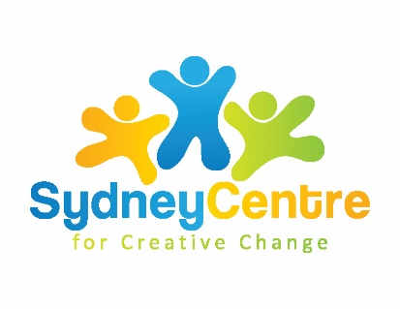
Holding Space Resources

Free Meditation/ Mindfulness Activities and Apps

Free app, daily mindfulness practices
https://www.smilingmind.com.au/smiling-mind-app
Smiling Mind - Smiling Mind is a unique tool developed by psychologists and educators

free app, mindfulness, meditation, yoga exercises
https://www.stopbreathethink.com/
check in with how your feeling, meditation and breathing exercises

free meditation classes – live and recorded
https://www.freemeditation.com.au/
Thoughtless awareness, also known as mental silence, is the basis of good health and wellbeing. Sahaja Yoga meditation provides this experience.

Headspace – guided 10 minute meditation
https://www.headspace.com/meditation/10-minute-meditation
Headspace provides guided meditations, animations, articles and videos, all in distinct style.

Free meditation podcast – daily
https://podcasts.apple.com/nz/podcast/daily-meditation-podcast/id892107837
Mary Meckley takes you on a weekly journey to manage your emotions. New themes each week based on an emotion with different daily meditation techniques to manage stress triggers.

Free meditation course for beginners
https://phuket-meditation.com/free-online-meditation-course/
Dharana Phuket meditation Centre – Buddhist tradition

Course on Jewish meditation and mindfulness – series
https://www.chabad.org/library/article_cdo/aid/1442811/jewish/On-Mindfulness-and-Jewish-Meditation-Part-I.htm

world community of Christian meditation
https://www.wccm.org
The World Community teaches the Christian tradition of meditation. Explore the rich context of a simple practical wisdom that brings the truths of faith alive in our own experience.

Free Meditation/ Mindfulness Articles and Tip Sheets

9 simple ways to calm yourself
https://www.psychologytoday.com/au/blog/the-mindful-self-express/201506/9-ways-calm-your-anxious-mind

14 instant ways to calm yourself
https://www.everydayhealth.com/columns/therese-borchard-sanity-break/10-quick-ways-to-calm-down/

22 mindfulness activities – positive psychology
https://positivepsychology.com/mindfulness-exercises-techniques-activities/

Article – should you meditate?
https://www.psychologytoday.com/au/blog/the-social-brain/201904/should-you-meditate

Article – benefits of Mindfulness
https://www.helpguide.org/harvard/benefits-of-mindfulness.htm?pdf=14945

Free Meditation/ Mindfulness Art and Craft Activities

Mindfulness colouring in sheets
https://www.betweensessions.com/wp-content/uploads/2014/02/mindfulness-coloring-book-4_25-16.pdf

Mindfulness colouring in sheets
https://www.actbelongcommit.org.au/assets/resources/targeted/mental-health-recovery/2.-mindful-colouring-in.pdf

Article – origami and mindfulness
https://www.psychologytoday.com/au/blog/urban-survival/201609/5-ways-origami-boosts-mindfulness

Origami activity guides – pdf links
https://www.origami-fun.com/printable-origami.html

breathing exercises

10 breathing exercises
https://www.healthline.com/health/breathing-exercise#alternate-nostril-breathing

Mindful breathing – 5-minute tutorial
https://www.mindful.org/a-five-minute-breathing-meditation/

Headspace – tips, 1-minute breathing exercise
https://www.headspace.com/meditation/breathing-exercises
Headspace tries to improve the health and happiness and has millions of users in more than 190 countries

Free app – Reach Out Breathe - APPLE
https://au.reachout.com/tools-and-apps/reachout-breathe
only available on apple

Meditation exercises for kids
https://www.stopbreathethink.com/kids/
from Stop Breathe Think

12-minute breathing meditation – youtube
https://www.youtube.com/watch?v=zPgwQFU1Cwc

