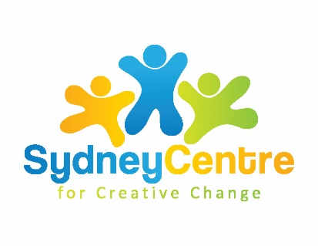
Holding Space Resources

Thank-you to Liana Lowenstein for sharing her wisdom in this webinar. You can check out Liana's resources and webinars:

Her website has many FREE resources including an eBook, articles, techniques, and newsletter: http://www.lianalowenstein.com

Webinar (recorded in the USA on May 12): Tips and Techniques for Online Therapy with Children: https://corewellceu.com/event/home-child-teletherapy#utm_source=liann&utm_medium=email&utm_campaign=Tips%20recorded%20webinar
Webinar in Australia: What’s Going’ On? An Innovative Assessment Model for Children and Teens: https://www.apdtraining.com.au/news/2020/05/29/whats-goin-innovative-model-assessing-children-and-teens

YouTube: https://www.youtube.com/user/lowensteinliana

Pinterest: https://www.pinterest.ca/lianalowenstein/boards/

Facebook: https://www.facebook.com/lianalowensteinsocialworker

Twitter: https://twitter.com/LianaLowenstein

Liana’s books available on amazon: https://www.amazon.com.au/s?k=liana+lowenstein&ref=nb_sb_noss_1

