Embracing the Wild Beyond
2020 Retreat Registration Form
Thank you for completing this form. Please be assured that the
completed form is seen only by the retreat facilitator and kept in strict confidence.
Please feel free not to answer a question if it does not feel right for you.
Date:
Surname First Name:
Residential Address:
State: Postcode:
Country:
Email Address:
Permission to be on Email list: □Yes □No
Mobile/ Home phone:
Emergency Contact Number:
Emergency Contact Person:
Occupation: Date of Birth:
How did you find out about this retreat?
What would you like to gain from participation in this retreat?
Family Info (Please tick or highlight):
□Single □Partnered □Partnered but living separately
□Divorced □Widowed □How long ago?
□Children? How old are they?
What gives you pleasure in your life?
Do you have any current medical, psychological or psychiatric conditions?
What are your greatest worries?
Any additional information you would like to convey?

Retreat Venue

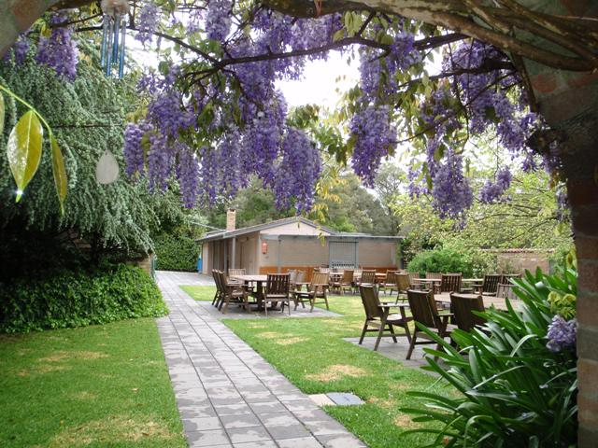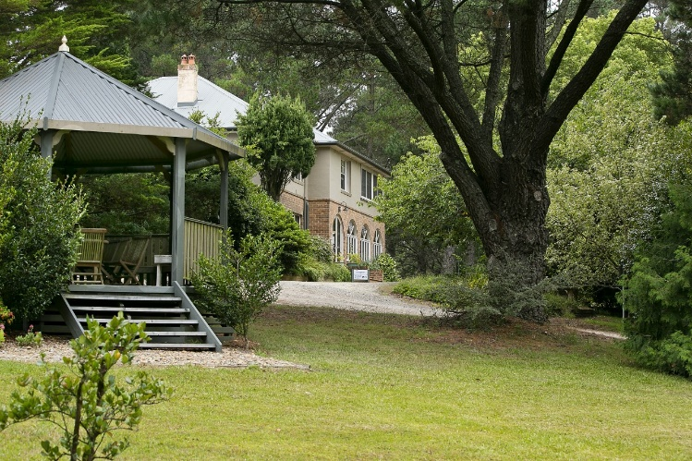
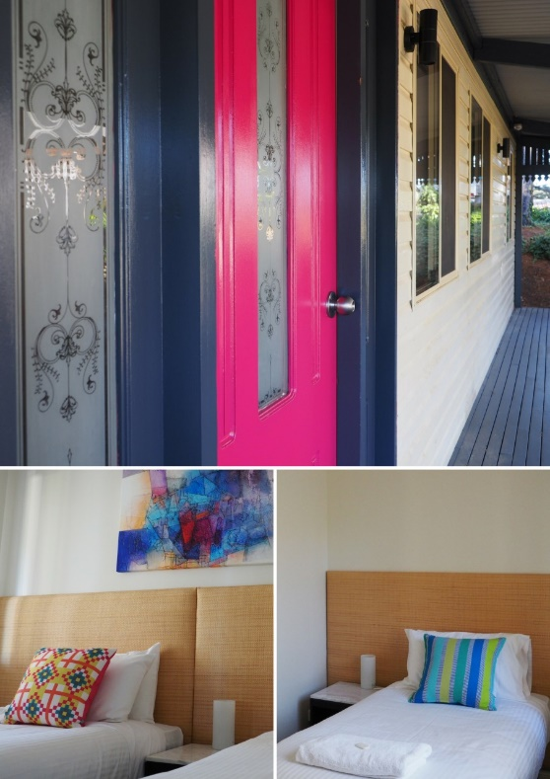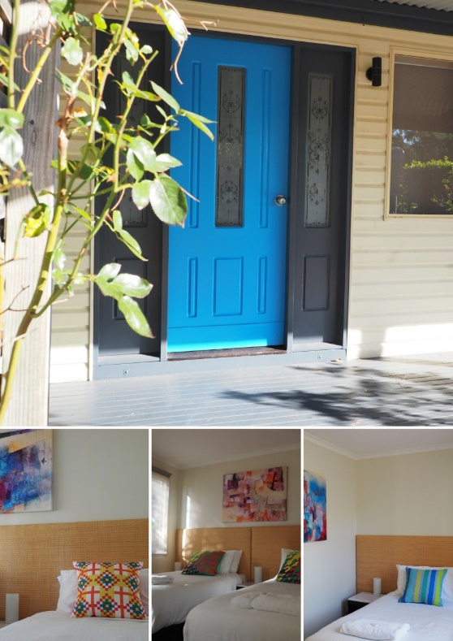

Set within 9 acres of manicured gardens in Bundanoon in the Southern Highlands, NSW our tranquil Retreat Centre comprises an historic house, two 4-bedroom lodges and beautiful tranquil gardens.
The beautiful Southern Highlands is a 90-minute drive from Sydney or Canberra and the Centre is situated just 5 minutes from the train station, medical clinics, pharmacy and other shops. Free parking is provided.
The nature and beauty of the area provide an escape from the stresses of everyday life and an ideal environment for walking, talking and connecting with self, others and with nature.
Retreat Centre address is 13-33 Ellsmore Rd, Bundanoon NSW, Australia.

Retreat Inclusions

What's included:
- Teaching - 5 day retreat program: 6 pm Tuesday 9th June – 1 pm Saturday 13th June, 2020
- Four nights accommodation at the Retreat Centre from Tuesday 9th June - Friday 12th June, 2020
- Daily Meditation or Yoga Practice
- All meals with delicious fresh organic menus prepared by our chef using our SLOW food method – Seasonal, Local, Organic and Whole
- The beauty and bush land of the Southern Highlands
- Bushwalking in Morton National Park
- Bundanoon village with great coffee shops and shopping (5 minute walk)
- Gardens & Gazebo – areas for inspiration, reflection, reading or quiet times including Ruth Cracknell garden, rose garden, vegetable garden
- Labyrinth – an ancient tool with a meandering but purposeful path. Walking the circuit of a Labyrinth uses the right brain and draws on our creative intuitive side in a search for possibility.
- Abundant wildlife – birds, kangaroos, echidnas, wombats
- Access to massage therapists (optional extra)
- 22 Professional Development Hours (for mental health professionals)
Accommodation Details and Food Requirements

For Twin share or double bookings please indicate details for both parties.
If you are happy to share a room with another retreat participant, please tick here and we will assist in arranging this. □

If you travel on your own but wish to share with a specific participant please give us their name here____________________________________________________________.

Guest 1
Surname: Click here to enter text. First Name: Click here to enter text.
Date of Birth: Click here to enter text.
Any Dietary Requirements: Click here to enter text.

Guest 2
Surname: Click here to enter text. First Name: Click here to enter text.
Date of Birth: Click here to enter text.
Any Dietary Requirements: Click here to enter text.
Payment Details
I would like to enrol for: (please circle all that apply)
Single*:

Retreat Payment by 28th February 2020 Early Bird $ 2295

Retreat Payment after 28th February 2020 Regular $ 2395

Twin Share/Double*:

Retreat Payment by 28th February 2020 Early Bird $ 1795

Retreat Payment after 28th February 2020 Regular $ 1895

*All payments are in Australian Dollars

PAYMENT

Please click HERE for Link to Online Retreat Payment

Please go to the end of the registration form to accept Terms and Conditions

Retreat Cancellations

Please read and understand the cancellation policy before making a reservation. While no one books with the intention of cancelling their retreat, I understand that unexpected things do happen. To avoid disappointment, you may want to purchase travel insurance once you have made your reservation.
Definitions
“Cancellation” is defined as not attending your scheduled Retreat,
“You” refers to the guest booking a Retreat.
“I” refers to Jacki Short.
Travel and Cancellation Insurance
In booking this retreat, you may choose to take out travel insurance. Please be sure that your insurance policy covers you for TRIP CANCELLATION. Depending on the policy and conditions, travel cancellation insurance will pay for some or all cancellation fees. With most agencies, insurance must be purchased within 14 days of making your reservation.
Guest Cancellation Policy
If you cancel your trip, I may not be in a position to offer refunds. I will gladly transfer your credit to another guest you nominate. Depending on when you cancel, cancellation penalties may apply.
Fees are determined by the following schedule:
Cancellations received before 7th March, 2020 incur 50% cancellation fee.
Cancellations received between 7th March 2020 and 7th April, 2020 incur 75% cancellation fee.
Cancellations received after 7th April 2020 incur 100% cancellation fee.
Exceptions to this policy cannot be made for any reason. I do not offer credit for a guest arriving late or leaving early. While I have never cancelled a retreat to date; if I must cancel the retreat for any reason, you will receive a refund of your payment, constituting a full settlement. I am not responsible for your expenses incurred in preparation for any cancelled retreat, such as airline tickets, loss of work, and/or other costs associated with preparing for your trip.

PRIVACY POLICY

I acknowledge and respect the privacy of individuals. Information is collected solely for the purposes of processing your application, booking or enquiry. It will not be shared with any third party. The provision of information is voluntary, but if not supplied, I may be unable to process your application, booking or enquiry. You have the right of access to, and alteration of, information concerning yourself in accordance with the Privacy Act.

Please note: By typing your name below and ticking the box you agree with the given policies and your printed name is taken as signature:

I agree ☐

Date: Please print name:

Please return the completed form to: info@sydneycentreforcreativechange.com.au
For questions please contact Jacki on 0411 209 802

